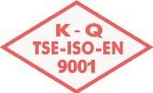



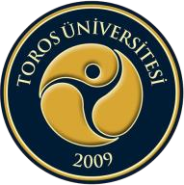
TOROS ÜNİVERSİTESİ MYO AŞÇILIK PROGRAMI 2. SINIF 2018-2019 BAHAR DÖNEMİ HAFTALIK VİZE SINAV PROGRAMI

GÜN  SAAT | PAZARTESİ  02.04.2018 | SALI  03.04.2018 | ÇARŞAMBA  04.04.2018 | PERŞEMBE  05.04.2018 | CUMA  06.04.2018
08:10-09:00
09:10-10:00
10:10-11:00
11:10-12:00
12:00-13:00
13:10-14:00
14:10-15:00
15:10-16:00
16:10-17:00

