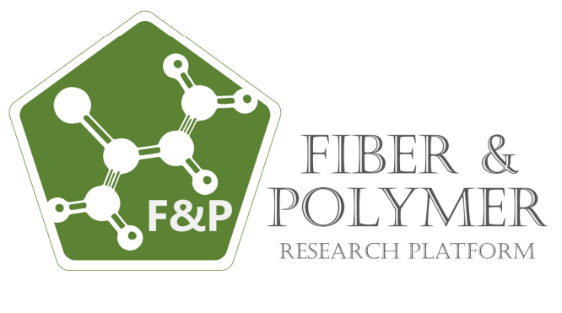

15. Uluslararası Lif ve Polimer Araştırmaları Sempozyumu
8-9 Kasım 2024, İzmir Bakırçay Üniversitesi
15th International Fiber and Polymer Research Symposium
8-9th Nov 2024, İzmir Bakırçay University - İzmir - Turkey
1th October 2024
Dear Fiber and Polymer Researcher,
The 15th International Fiber and Polymer Research Symposium (15th ULPAS) will be held on Nov 8-9, 2024, at the lovely and excited with research campus of İzmir Bakırçay University.
The symposium will focus on "Bio-materials, Bio-polymers, Sustainability, Composites, Smart Textiles and Related Research”. But it will encompass all topics related to polymers and fibers, as indicated on the symposium website
We sincerely invite you to participate in the 15th ULPAS symposium and present your latest research findings.
- The papers submitted and presented at the symposium will be evaluated by an Independent Award Committee and BEST PAPER AWARD and BEST POSTER AWARD will be awarded.
- The papers presented at the symposium will be selected for the publication at the Journal of Innovative Engineering and Natural sciences (https://jiens.org).
To register and upload your paper files, please click on the following link: https://ulpas.org/15
Your participation will contribute to making this symposium an event of knowledge sharing, technological dissemination, and brainstorming.
We kindly request you to spread the word about this symposium among your students, collaborators, and colleagues to encourage maximum participation.
We would be delighted to host you at the 15th ULPAS symposium.
Best regards.
On Behalf of Fibers and Polymers Research Platform
Prof. Dr. Abdulkadir HIZIROĞLU
Prof. Dr. Cem GÖK
Prof. Dr. Yusuf ULCAY
Prof. Dr. Ali DEMİR
Enc:
- 15. ULPAS Poster
- 15. International Fiber and Polymer Research Symposium-2024-Organising & Scientific Committee
- 15. International Fiber and Polymer Research Symposium FULL MANUSCRIPT Writing Guidelines
You can reach the Book of Proceedings of the previous ULPAS by clicking the following link;
https://ulpas.org/15/Home/Content?id=85

